Copy/Paste Image and first few words of question - Place Tallies Below Image if You Agree

More indexes

1Model objects hold the application’s data and “business logic.” true |

2 When the OS Destroys… 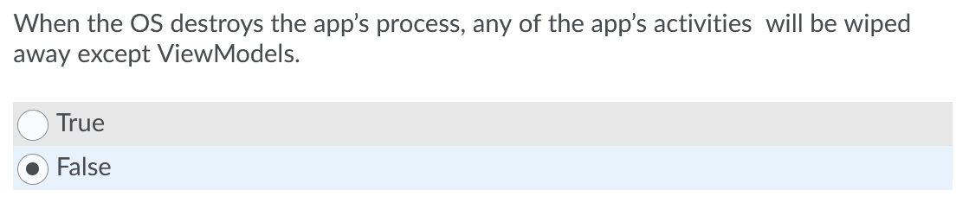

3

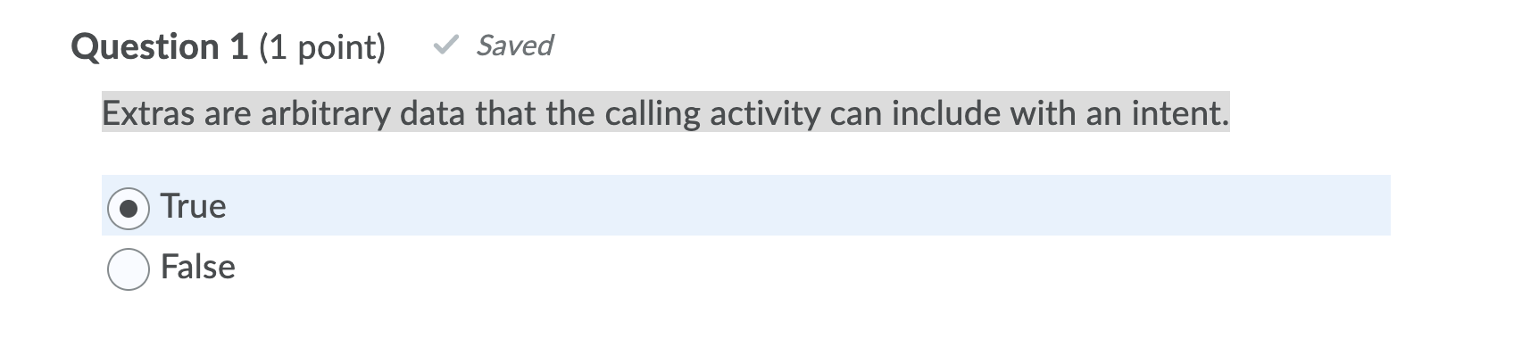

4 In an activity, you can get a reference to an inflated widget by calling Activity.findWidgetById(int). FALSE l

5An activity could also be fully visible but not in the foreground if the user is viewing two activities in multi-window mode (also called “split-screen mode”). The resume state will represent that activity. False

True

6 You can call Intent.putExtra: TRUE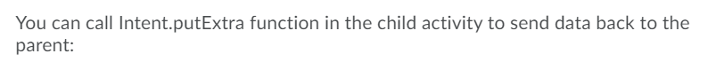

7 The view objects are not inflated into and available in memory until after setContentView(…) is called in onCreate(…). TRUE

An intent is an object that a component can use to communicate with the OS

false

8 Only one activity across the entire system can be in the resumed state at any given time TRUE

9 Fragment transactions are used to add, remove, attach, detach or replace fragments in fragment list. TRUE (from book directly)

10 An intent is an object that a component can use to communicate with the OS

True

11 A container view ID parameter in the function add of FragmentTransaction tells the FragmentManager where in the activity’s view the fragment’s view should appear. True

12 The Main activity overrides onActivityResult(…) to pull the value out of the result sent back from Child activity. I wanna guess true?



13 You can view and manage the files associated with your project by using the Android tool window . TRUE Isn't it Project Tool window? It’s project  
^ yeah, i think this is false because project and Android tool windows are different but the textbook says project tool window

So true or faalse

Nah

14 The class file for MainActivity is in the app/java directory of your project. TRUE

15The targetSdkVersion value is a hard floor below which the OS should refuse to install the app. FALSE

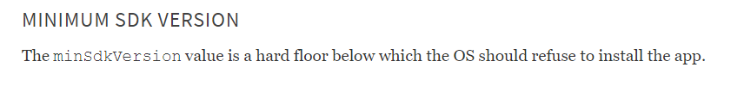

Question 4

|  |  |
| --- | --- |
|  |  |
|  | * False |False |

16View state is restored after onCreateView(…) and before onStart(). Setting the TextWatcher listener in onCreateView(...) , the listener will be hooked up after the view state is restored.

True   
 False?

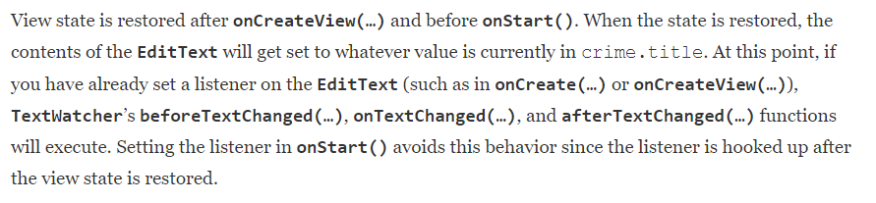

17 An app’s process can be destroyed by the OS if the user navigates away for a while and Android needs to reclaim memory. TRUE

18To save UI state data and use it to reconstruct the activity so that the user never even knows the activity was destroyed is to store data in a ViewModel.

F

19 The OS calls Activity.onSaveInstanceState(Bundle) any time an activity that is not finished moves to the stopped state (such as when the user presses the Home button and then launches a different app). TRUE (from book quote)

20 You inflate the layout for the fragment’s view and return the inflated View to the hosting activity by calling the fragment lifecycle function: onCreateView(LayoutInflater, ViewGroup?, Bundle?). TRUE (from book quote)

21 The steps to create a UI fragment are the same as those you followed to create an activity: FALSE

22 To add an extra to an intent, you use Intent.putExtra(…).

Question 6 options: TRUE (found in textbook)

|  |  |
| --- | --- |
|  |  |
|  |  |

23 When a user press a button, you want to do something in response, then you should code the function setOnPressListener.

Question 7 options:

|  |  |
| --- | --- |
|  | True |
|  | * False |

24 In Android, a controller is typically a subclass of Activity or Fragment TRUE

25 An activity is responsible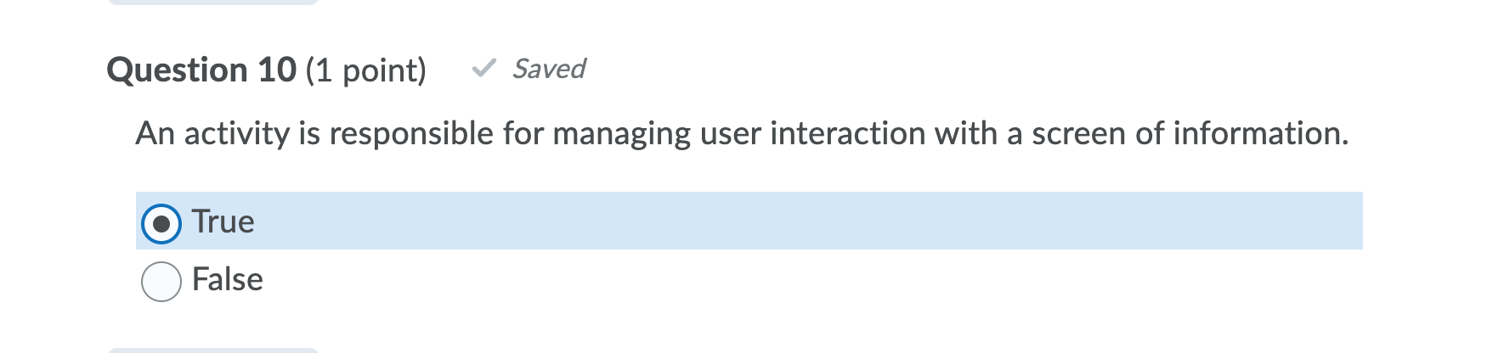

26 Model objects have some knowledge of the UI… FALSE

27 To display a toast on the screen, you call the static function Toast.makeText(Context!, Int, Int).

False

28 you will send a string value as a NewIntent on the intent that is passed into StartActivity(Intent). False

29 FragmentManager is responsible for adding the fragments’ views to the activity’s view hierarchy and driving the fragments’ lifecycles. TRUE (from textbook)

30 Saved instance state is data the OS temporarily stores outside of the activity. You can add values to saved instance state by overriding Activity.onSaveInstanceState(Bundle). TRUE (from textbook)

31 The simplest way one activity can start another is with the startActivity(Intent) function. TRUE (page 122 in the textbook 144 in the file)

32 The manifest is an XML file containing metadata that describes your application to the Android OS. True

33You run an app from Android Studio, then press Home button. Your MainActivity of the app will receive calls to onPause(), onStop(), and onDestroy().

-False

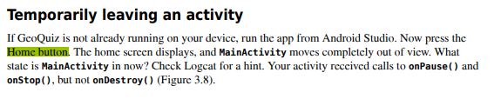

34 The onCreate(Bundle?) function is called when an instance of the activity subclass is created. TRUE (from textbook)

35 To retrieve the value from the extra, you will use Intent.getBooleanExtra(String, Boolean). TRUE (found in textbook)

36 You inflate the fragment’s view in Fragment.onCreate(Bundle?). FALSE  
(Textbook: *Also, note what does not happen in Fragment.onCreate(Bundle?): You do not inflate the fragment’s view*.)

37

**wrap_conten**t view will be as big as its contents require.

True

38 When the parent activity wants to hear back from the child activity, it calls the Activity.getIntent() function. Uses Activity.startActivityForResult() - false

-Evidence to supp **False**



Only reference in the book right here ^ im gonna go with true

39 Extras are arbitrary data that the calling activity can include with an intent. TRUE (from textbook)

40 Since the view objects are not inflated into and available in memory until after setContentView(…) is called in onCreate(…), you use lateinit on your property declarations to indicate to the compiler that you will provide a null View value before you attempt to use the contents of the property. FALSE

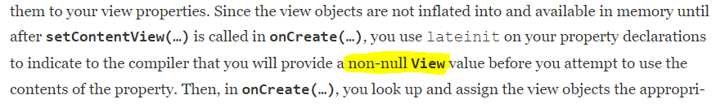

41 You use a LinearLayout when you want views arranged in a single column or row. TRUE (from textbook)

42 Activity.setContentView inflates a layout and puts it onscreen. TRUE

43 By convention, a layout file is named based on the activity it is associated with: Its name begins with activity_, and the rest of the activity name follows in all lowercase, using *periods* to separate words FALSE   
(Textbook: … using *underscores* to separate words …)

44When would you lower the target SDK? New SDK releases can change how your app appears on a device or even how the OS behaves behind the scenes. If you have already designed an app, you should confirm that it works as expected on new releases. Check the documentation at developer.android.com/​reference/​android/​os/​Build.VERSION_CODES.html to find potential problems. TRUE

45 Every activity in an application must be declared in the manifest so that the OS can access it. TRUE

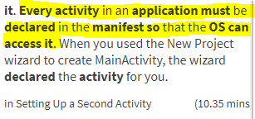

46The add(…) function in FragmentTransaction has two arameters: a container view ID and the created Fragment. The container view ID is the resource ID of the FrameLayout that you defined in Main activity.

TRUE

47 The object that you create to respond to an event is called a listener, and the listener implements a listener interface for that event. **TRUE** (FROM BOOK)

48Controller objects contain “application logic.” Controllers are designed to respond to various events triggered by view objects and to manage the flow of data to and from model objects and the view layer. true

49 The TextWatcher listener for an EditText reacts to data output.

Data input, no? So false? Yes false. False

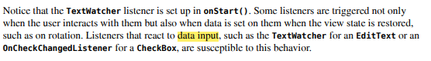

50 A layout is made up of definitions written in XML. - True

When an activity calls startActivity(Intent), this call is sent to the ActivityManager. The ActivityManager then creates the Activity instance and calls its onCreate(Bundle?) function.

True